OIL Investment Opportunıtıes IN NIGERIA
OPEN SOURCES INTELLIGENCE REPORT
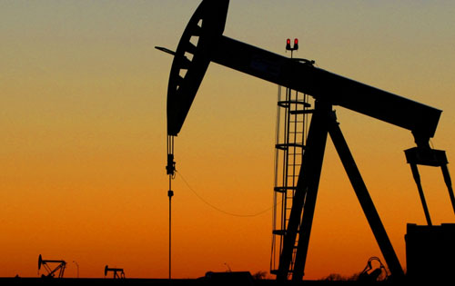
Prepared by: T.Golbasi Y.Yunusa A.Ahad

Advanced Information Security Report
Yasar University, Izmir, Turkey

Requirements
Our wealthy investor requests from us to answer if investing in Nigerian oil fields is worthy business.
Milestones
- December 10th Interim report
- December 17th Draft report
- December 24th Final report
Requirements Analysis
Our goal is to find out investment opportunities in Nigerian oil fields.
We can split this goal into several parts:
- What is oil?
  - What are uses of oil?
  - How oil production is done?
- What is future of oil?
  - What is supply figures in oil?
  - What is demand figures in oil?
  - What is historical performance of oil prices?
  - What is forecast for oil prices?
- What is the status of Nigerian oil fields?
  - What is the history of Nigerian oil fields?
  - Which companies currently invested?
  - What are their returns?
  - How we send oil to customers?
- Why should we choose Nigeria for our investment?
  - What are the incentives for investing in Nigeria?
  - What are risks of investing in Nigeria?
  - What are regulations over oil production?
  - What are costs of investing in Nigerian oil fields?
Following approaches to achieving the objectives have been identified
Problem Solving Techniques
In order to answer these questions we will use special techniques. These will include:
- Paraphrase:Restate the problem using different words without losing the original meaning. Trying to say the same thing with different words puts a slightly different spin on the meaning, which triggers new perspectives and informative insights.
- 180 Degree: Turn the problem on its head. Taking the opposite view not only challenges the problem's underlying premises but also directly identifies what is causing the problem.
- Broaden the focus: Restate the problem in a larger context, Look at the implications of the initial problem beyond the confines of your own organization.
- Redirect the focus: Boldly, consciously change the focus. Using creative thinking, look at the problem from an entirely different perspective.
- Ask “why”: Ask “why” of the initial problem statement. Then formulate a new problem statement based on the answer. Then ask “why” again, and again restate the problem based on the answer. Repeat this process a number of times until the essence of the “real” problem emerges. Restating a problem several different ways is a divergent analytical technique that opens the mind to alternatives.
Source: Morgan D.Jones. The Thinker's Toolkit. New York:Three Rivers Press,1995

Open Source Information Sources
An important subset of open source information is called Grey Literature. The Interagency Grey Literature Working Group(IGLWG) is defined as follows:
“Grey literature, regardless of media, can include, but is not limited to, research reports, technical reports, economic reports, trip reports, working papers, discussion papers, unofficial government documents, proceedings, preprints, research reports, studies,dissertations and theses; trade literature, market surveys, and newsletters. This material cuts across scientific, political, socio-economic, and military disciplines.”
The ability to search internet or in essence, millions of pages of text within seconds, has proven to be the reason for the rise in popularity of open source information.
Open sources will be used are:
- Governmental Websites
  - Official Website of the Nigerian Investment Promotion Commission (NIPC) http://www.nipc.gov.ng/
  - Official Website of the Nigerian Export Promotion Council http://www.nepc.gov.ng/
  - Official Website of the Federal Ministry of Finance http://www.fmf.gov.ng/
  - Official Website of the Nigeria Petroleum Technology Development Fund http://www.ptdf.gov.ng/
- Search Engines
  - www.google.com
  - www.bing.com
- Academic Databases
  - scholar.google.com
  - African Journals Online (AJOL) http://www.ajol.info/
  - Web of Knowledge http://www.webofknowledge.com/
  - The Information Bridge: U.S. Department of Energy Scientific and Technical Information http://www.osti.gov/bridge/index.jsp
  - OpenGrey Grey Literature database http://www.opengrey.eu/
- News Websites
  - Reuters www.reuters.com
  - BBC News http://www.bbc.co.uk/news/world/
  - Vanguard Nigerian News website http://www.vanguardngr.com/
  - NigeriaWorld Nigerian News Website http://www.nigeriaworld.com/
  - The Guardian Nigerian News Website http://www.ngrguardiannews.com/

Data Collection
For the purpose of making use of the techniques involved in finding data/information in writing open source intelligence report for authentication, we sources the information through Google search using different search engine by direct link to governmental sites and organizational sites to ensure all the resources were from true sources and will at the same time make the customers have confidence in investing their money in Nigerian oil production. For example the information was derived some in form of text to be store while others in form of images. Therefore, the storing aspect of the data were done with credibility measure and specific storing format to make sure the data were written based on intelligence reasoning.
Credibility Measure: The degree to which people believe and trust what other people and organizations tell them about a particular product or service, and this were confirmed by following any possible hyperlink during data gathering.
For example: the site www.nnpcgroup.com was analyzed as follows;
Source Number: <can be any number but unique>
Source Name: < NNPC Directory>
Source Link : <http://www.nnpcgroup.com>
Credibility: <credible>
The illustrated sample of how the data was gathered in order to suite the investors to feel free of the information source and the detail will be discuss in the next chapters.
Source Evaluation
In order to evaluate our sources effectively we will be using a evaluation checklist as follows:
1-Authority
- Is it clear which organization is behind the contents of the page?
- Is there a link to a page describing goals of the organization?
- Is there a way of verifying the legitimacy of this organization?
2-Accuracy
- Are the sources for any factual information clearly listed so they can be verified in another source?
- Is the information free of grammatical, spelling, and typographical errors?
3-Objectivity
- Are the organization's biases clearly stated?
- If there is any advertising on the page, is it clearly differentiated from the informational content?
4-Currency
- Are there dates on the page to indicate:
  - When the page was written?
  - When the page was first placed on the web?
  - When the page was last revised?
- Are there any other indications that the material is kept current?
5-Coverage
- Is there an indication that the page has been completed, and is not still under construction?
- Is it clear what topics the page intends to address?
- Does the page succeed in addressing these topics, or has something significant been left out?
- Is the point of view of the organization presented in a clear manner with its arguments well supported?
Source:http://olinuris.library.cornell.edu/ref/research/webcrit.html

Introduction
Today's world runs with oil. This is not an exaggeration. From gasoline in our cars to the plastic in our computers to the detergents we put in dishwashers, we rely on it deeply. It cannot be understated just how strong of a role it plays in our economy and politics. It runs our cars, trains and trucks that carry our goods, tracktors that harvest our food. We need oil in power plants to generate electricty. We need it to heat our homes. And our dependance not limited to these and growing each day. Price of oil sky rocketted over the years because of our dependance on it. The need for oil destroys governments, and replaces them with others in all over the world.
History
The dependance on oil was not like this many years ago. Oil was known since ancient ages and used for sealing boats and lighting lamps. But its scarcity limited its use. This is changed in 1859 when Edwin Drake struck oil at 69 feet below ground in a well in Pennsylvania. His success spurred wells to be drilled in other locations around the world. These drills helped for other uses of oil such as heating homes. These new uses spurred further production and this led to newer inventions. With the refiniment of gasoline-powered internal combustion engine in the 1880's and its use in the car it became a hot commodity in the world. Its impact on economy and politics grew very large.
United States's involvment in World War II started with its oil ships blockade from Indonesia to Japan. Japan had to attack U.S. Naval base Pearl Harbor to secure their oil supplies. Hitler's desire for oil power forced him to unsuccessful attacks on Russia and North Africa. In 1973 U.S helped Israel in Yom Kippur War and The Organization of the Petroleum Exporting Countries (OPEC) embargoed U.S.. This led to a colapse of the American auto market and an economic decline because United States was't able to produce enough oil for their needs. After the embargo price of oil quadrupled. United States were in trouble because U.S. Support of the Shah of Iran was overthrown by Islamic Revolution increasing the embargos effect. United States's two wars in Iraq was a result of their attempts to control large supply of oil in Middle East.

Usage
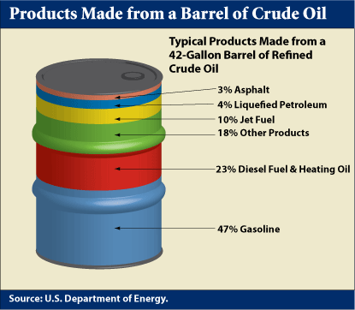
Crude oil is processed in oil refineries into useful materials. Oil refineries can produce different petroleum products according to the market demand. These materials mostly consist of energy carriers fuel oil and gasoline. These fuels can include diesel fuel, jet fuel, heating oil and heavy fuel oils. Heavy fractions can be used in making roads with asphalt.
Refineries also produces chemicals that are used to produce plastics and other materials.
United States is by far the largest user of oil consuming around 19,1 million barrels per day it is followed by China 9,4 million barrels. United States consumes more than China, Japan and India combined in 2010. Those three countries are 2nd,3rd and 4th in crude oil consumption respectively. We will give further information about crude oil demand later on.
Creation
Crude oil believed to be formed from compression and heating of ancient organic materials over long periods of time. Oil is formed from planktons and algae that died and their remains settled on ocean floor. Their remains are covered with sediment. Eventually temperature and pressure became so high that remains converted to kerogen and then to natural gas or crude oil. This sediment is known as source rock.
If source rock has openings in it oil can move through it and can go upwards direction. The oil can push their way up if source rock has faults like those caused by earthquakes. If oil finds its way up to the surface it will leak out of the ground. This is how ancient cultures found out oil. And companies use satelite imagery to find out oil leaks around the world to find new crude oil deposits to drill.
We are only concerned with oil that is profitable and this oil needs to be trapped in the ground. This happens only if the sediment of oil reserve is not faulty. And this sediment has to be large as well to create a large enough oil trap. Diagram below shows some types of oil traps under the ground. Pink area is salt, gray is rock layer and blue is oil.
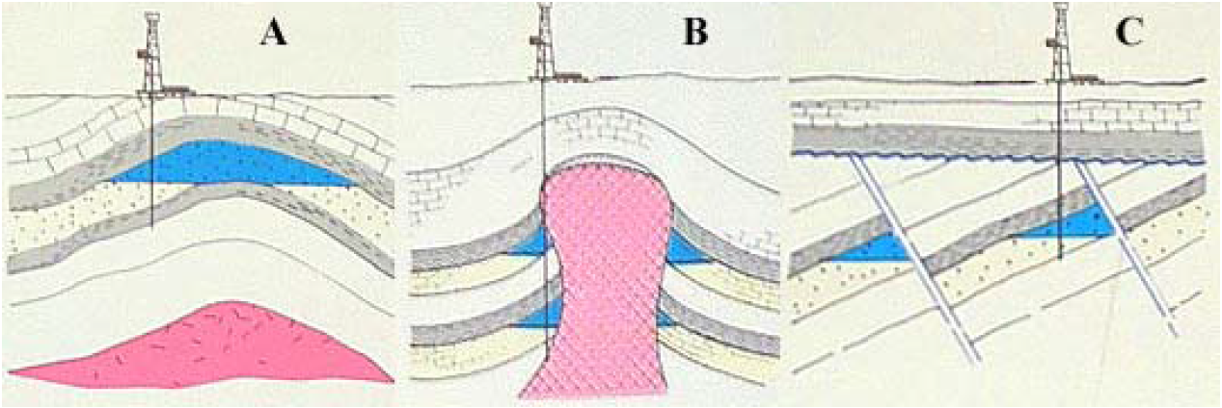
A-Anticlinal trap B-Salt dome trap C-Fault block trap
Exploration

Mineral rights
Production
Refiniment
Seperation
Conversion
Purification
Historical Performance
Supply
Demand
Peak Oil
Forecasts

- Why should we choose Nigeria for our investment?
A lot has made our mind to choose Nigeria for investments, particularly in the oil sector of the country, which can be explain in the next section:
Nigerian government accepts the private sector as the engine of growth and creator of wealth, therefore its responsibility is to provide enabling environment for the investors to operate conductively.

  - What are the incentives for investing in Nigeria?
The factors that will encourage investors to have interest in investing in Nigerian oil may largely depend on the purpose of the investment available in the country, which is obviously stated below:

- Being the best oil production country in African Continent and one of the world’s best oil production countries, ranked between 11th-14th (2011-2012, world position), investment opportunities greatly expected.
- ACCESS TO LAND
- Any Company incorporated in Nigeria is allowed to have access to land rights for the purpose of its activity in any state in the country. it is, however, a requirement that industrial companies comply with regulations on use of land for industrial purposes and with environmental regulations.

- Nigerian National Petroleum Corporation (NNPC):
Is a public organization that would, on behalf of government adequately manage all government interests in the Nigerian Oil Industry. Therefore, both foreign and domestic investors were being encouraged through improved fiscal incentives in the oil and gas industry. The organization has two major areas named as (Upstream and Downstream) with required investment opportunities for both foreigners and domestic investors
In the upstream and downstream sectors, the following are some of the areas where there are pressing needs for investors;
Upstream Activities:
- Petroleum Exploration and Exploitation.
- Construction and installation.
- Maintenance.
- Pipelines.
- Transportation support services.
- Manufacturing of consumable materials in exploration such as explosives, detonators, steel casting, magnetic tapes, etc.
Downstream Activities:
- Domestic production and marketing of liquefied petroleum gas (LPG).
- Manufacturing of LPG cylinders, distribution and development of simple, flexible and much less expensive gas burner to encourage the use of gas instead of wood and other fuels.
- Establishment of processing plants and industries for the production of refined mineral oil petroleum jelly grease.
- Establishment of chemical industries such as distillation units for the production of naphtha and other special boiling point solvents used in other food processing industries.
- Establishment of small scale industries to produce chemicals and solvents from natural gas, for example chlorinate methane, formaldehyde, acetylene, etc.

  - What are risks of investing in Nigeria?
Where there are benefits risk may probably arise knowingly or unknowingly.
Therefore, it is good to notice the following expected/ possible risks that
an investor may encounter in one way or others:
- Oil exploitation and conflict in the Niger Delta region of Nigeria: This is the region where oil production is taking place located in south-south part of the country and some part of south west and south east of Nigeria. In this area a lot of community group work against both government and investors as stated below;
- Terrorism threat: There is a terrorist group called MEND meaning “Movement for the Emancipation of Niger Delta” is a militant group seeking to assume control of Nigeria’s energy resources in the Niger Delta where they involved in protesting government by all means with aim of seizing power.
- Kidnap: There is also kidnapping threat in some part of Nigeria particularly in the Niger Delta region mainly for financial or political gain and can be motivated by criminality or terrorism, as shown in the picture below;


Militant Emancipation Group in Niger Delta Region of Nigeria
- Scams; The scams come in many forms, and can pose great financial loss to victims. Therefore, know where and who you are sending money to. And look for authorized dealer in exchange and conversion of funds.
- Infrastructure ; some factors associated with unavailability of societal amenities may cause risk in the process of investment like electric power supply, road congestion as result of bad or substandard roads and others.
- Weather; Nigeria experiences heavy rainfall during the wet season (June-October) and flash flooding can occur, water borne disease may poses risk during rainy season.

  - What are regulations over oil production?
Petroleum operations and activities are regulated primarily by federal government agencies, although some state governments and local governments also have regulations and bye-laws that may affect activities in oil and gas industry.
For successful investment in Nigeria both foreign and domestic, one has to follow the following guidelines in order to achieve the goal of investing Nigeria particularly in the oil sector;
- Government License: Any investor or Private person most register with government, because, it is stated that every property and mineral resources are in control of the federation and shall be managed by the federal government directly or indirectly under some agencies like NNPC and can assisted by other organizational bodies authorized by government like NIPC, IOCs, etc. for example the petroleum act provide three types of licenses for upstream operations: Oil Exploration License (OEL), Oil Prospecting License (OPL) and Oil Mining Lease (OML).
- There is also a general requirement for both International Oil Companies (IOCs) and the oil service companies to train Nigerians to fill specified positions in their companies.
- IOCs and oil service companies are allowed, subject to obtaining the necessary expatriate quota, to employ expatriates to fill key positions in their organizations. They are however required to train Nigerians over a period of time to take over from the expatriates.
- Nigerian Investment Promotion Council (NIPC): Act also states that no person who owns, whether wholly or in part, the capital of any enterprise shall be compelled by law to surrender his interest in the capital to any other person.
- The NIPC Act further provides that where there is a dispute between an investor and the government, the dispute can be resolved by any means agreed upon the parties or in accordance with the rules of the International Centre for Settlement of Investment Disputes (ICSID).

  - What are costs of investing in Nigerian oil fields?
Regardless of the underlying reasons for changes in oil prices, the cost of investment in any field can only be determine fundamentally in respect of understanding the company and sectors in which you invest, therefore make sure you do research or consult an investment professional prior to committing your money, so that you will have outlined information when predicting price changes to help ensure a profitable investment. Because;
- The oil market provides a diverse array of options for the potential investor. From indirect exposure via an energy-related stock to more direct investment in a commodity-linked ETF (Exchange Trade Fund), it trades like a stock, have no net asset value to be calculated every day.
- But the government has unified the price of its products with differentials in transportation costs due to distance variation.

